教学案例
Crazy Cat教学设计
基本信息
授课教师 | 尹悦 |  | 学 校 | 天津市河东区翔宇小学
授课年级 | 三年级 |  | 课程类型 | 绘本故事教学
单元名称 | N/A |  | 教材版本 | 外研社多维阅读系列 第三级
课文标题 | Crazy Cat |  | 授课时长 | 40mins
教学分析
本课教学内容分析 | 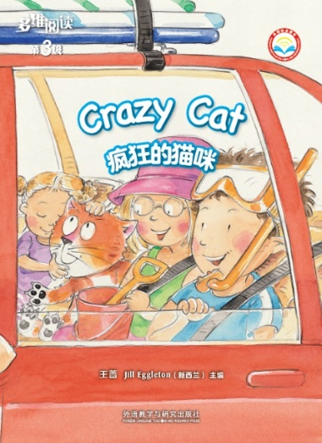  本课教学内容为绘本故事 Crazy Cat，故事选自外研社《多维阅读》系列绘本第三级。  故事讲述了爸爸带着三个孩子要去海边玩耍冲浪，由于担心家中猫咪吵闹故将其留在家中。但猫咪也想和家人一起出游，于是偷偷藏在车顶，途中被警察发现并及时制止，最后爸爸感叹猫咪的“疯狂”举动，决定带猫咪一起出游的故事。  通过这个故事向学生传达如何在安全合理的范围内满足自己的需求的主题意义，同时让学生意识到宠物也是重要的家庭成员。  故事运用一般过去时以记叙文四部分即发生、发展、高潮和结局进行语言组织，呈现故事情节。
学情分析 | 本课的授课对象为三年级的学生，在绘本故事学习之前，学生已经具备对动物如cat，家庭成员dad，交通工具car，情绪happy、sad、angry及方位词in、on的听、说、认读能力。文中对于学生来说难度较大的单词为crazy，短语为went down。  三年级的学生认知水平虽还处在初级阶段，但基本已经形成了相对完整的知识结构体系。在学习过程中渴望积极参与，用简单的英语表达自己的观点，具备初步的预测、理解、想象、分析的能力。
教学目标 | 通过本节英文绘本的学习，学生在学习结束时能够：  - 通过阅读、观察，合理预测故事发展，提取故事要素，获取故事大意，理解随着情节发生、发展，以及到结局时主要角色的情绪变化。  - 在阅读、经历故事情节的起伏发展中，借助文中标点符号体会人物情绪并尝试有感情地朗读。  - 通过独立思考及小组讨论的形式，解读角色的情绪变化，与教师一起建构story map梳理故事发展脉络，尝试用文本中的语言简单复述故事。  - 通过分析与探讨，对“疯狂”举动形成客观认识，同时理解宠物也是重要的家庭成员。
教学重点 | 通过story map来梳理故事的发展脉络，读懂故事并尝试用文本中的语言简单复述故事。
教学难点 | - 理解猫咪的情绪变化背后的原因。  - 分析猫咪举动，理解故事内涵。
教学资源 | 自制汽车教具，猫咪手偶，警察帽子，眼镜框，ppt课件，外研通点读笔。
教学过程
Stages | Teaching activities & Interaction patterns | Purpose |  |  | 活动层次 | Teaching Evaluation | Timing
Ⅰ.Warming up | Activity 1 Sing a song.  Active Ss’ background knowledge and prepare for the language output. | Use a song about feelings to create an active atmosphere. |  |  | 感知与 注意 | Ss are able to greet all the teachers, sing a song with T together and talk about their pets. | 1’
Ⅱ. Leading in | Activity 2 Discuss and lead in the topic.  Lead in the pet topic and have a discussion.  Questions:  - Do you have any pets?  - What do you think of your pet? | Use a pet topic to get Ss’ attention and talk about their pets. |  |  | 感知与 注意 |  | 2’
Ⅲ.Preview | Activity 3 Make predictions about the story and get the characters’ information.  Confirm the main characters and focus on the tricky word “crazy”, answer some questions by reading the cover page.  Questions:  - What can you see on the cover page?  - What’s the title? Who’s the man? How many kids?  - Do you think the cat is crazy? | Help Ss to develop a good reading habit by reading the cover page first. Predict what might happen after observing the characters. |  |  | 获取与 梳理 | Ss are able to know the title and characters of the story and make predictions according to the cover page. | 3’
Ⅳ.View | Activity 4 Clarify the storyline of page2-7 by answering the questions.  With the guidance of the following questions, Ss may clarify the storyline. At the same time, with the help of the teacher, guess and predict the following story by different contexts and pictures.  Questions:  Pages 2-3  - Where are they going? How do you know that?  - What does the cat want to do? （Go to the beach or stay at home.）  Pages 4-5  - Where is she now?  - How do the kids feel? Why are the kids happy, too?  - Did Dad agree? How do you know that?  Pages 6-7  - Where did Dad put the cat? How do they feel?  - Dad said “You cannot come”, why?  - Look at the cat! Is she saying something? What would she say?  Activity 5 Read the whole story and clarify the storyline of page 8-15.  Read and listen to the story by E-pen, pay attention to the tricky words and focus on the pronunciation and intonation.  Questions:  Pages 8-9  - Did Dad know about the cat? Why? What was Dad doing?  - What does Dad have on his list？What will Dad take to the beach?  - What will happen to the cat?  Pages 10-11  - How does the cat feel?  - Listen to the sound, who’s coming? Why?  Pages 12-13  - What did the police officer say?  - How does Dad feel? And the kids?  - How does the cat feel right now?  - What will they do with the cat?  Pages 14-15  - Where did Dad put the cat?  - What does Dad think about the cat? Why? | - Guide Ss to get information from pictures as much as possible, use imagination to guess, predict and complete the dialogue.  - Guide Ss to pay more attention on story details.  - Enhance the interaction between Ss and story.  Review the story from page 2-7 and have a brief understanding of the following story.  - Guide Ss to pay more attention on story details.  - Understand and think about the climax part.  - Analyze the reason and emotions of the characters.  - Deeply experience the feelings of characters. |  |  | 获取与 梳理  分析与 判断  获取与 梳理  分析与 判断 | - Ss are able to guess and predict the following story.  - Ss are able to guess, predict and experience character’s feelings.  - Ss are able to clarify the storyline by story details.  Ss are able to read and listen to the whole story by E-pen. Review and clarify the storyline by themselves.  - Ss are able to answer the key questions of story development, clarify the storyline.  - Ss are able to get the story details and experience different feelings of the characters. | 25’
Ⅳ. Review | Activity 6 Focus on the main line of the story and complete the story arc in group.  Ss may complete the story arc by using the known story factors.  Activity 7 Internalize the language and retell the story.  Practice and cooperate in group and retell the story according to the story arc.  Activity 8 Have a further discussion of the story, analyze and evaluate the cat.  Questions:  Do you think the cat is crazy?  Activity 9 Connect life to discuss.  Questions:  If you have the same problem in your daily life, what will you do? | Promote the process of internalizing the knowledge and help them to retell the story.  Lead Ss to internalize the language and have further expansions.  Lead Ss to express their opinions and evaluate the behaviors of the cat.  Lead students to control their feelings in daily life and consider their pet as a family member. |  |  | 获取与 梳理  批判与 评价 | Ss are able to finish the story arc.  Ss are able to experience the characters and retell the story with their partners.  Ss are able to express and analyze the process and opinions.  Ss are able to connect life by the main idea of the story. | 8’
Ⅵ. Homework | - Retell the story to your parents.  - Read the story of Sam the Big, Bad Cat. | Lead Ss to stretch mind by reading another story about cat. |  |  | 内化与 运用 | Ss are able to retell the story and read story by themselves. | 1’
Ss: Students T: Teacher IW: Individual Work GW: Group Work CW: Class Work
Teaching Evaluation: you can use "Ss are able to..."to describe if the sub-aim of the activity is achieved.
板书设计
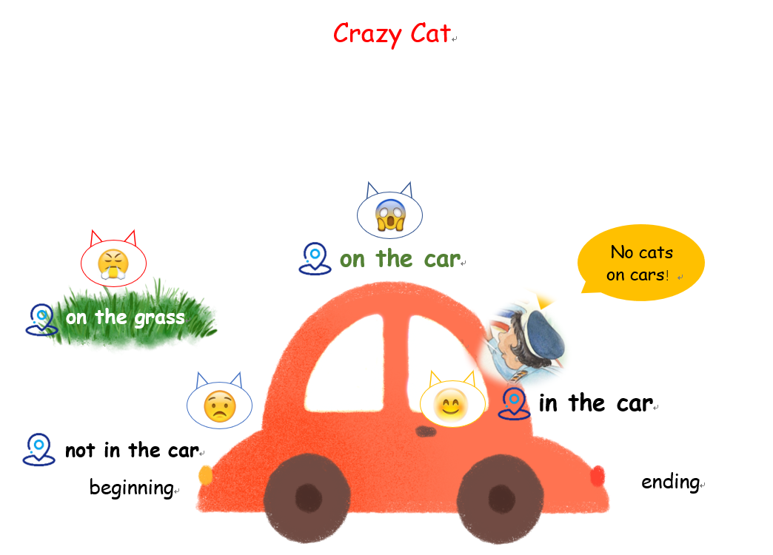

课文原文
Crazy Cat
Page 2-3: Dad looked in the car.
“The kids are here,” he said.
Page 4-5: “Look at the cat,” said the kids.
“She is here too.”
“The cat can not come,” said Dad.
Page 6-7: Dad put the cat on the grass.
“You can not come,” he said. “You will meowwww!”
Page 8-9: One, two, three kids.
Dad got in the car.
Dad looked at the kids.
“We can go,” he said.
Page 10-11: Dad and the kids went down the road.
“Look!” said the kids. A police car!
Page 12-13: A cat is on this car. No cats on cars!
Oh no! Come here!
Meoww!
Page14-15: Dad put the cat in the car.
“You are a crazy cat!” he said.

