附件1：教学材料文本
本附件包含四则本次评选活动限定使用的教学材料文本，其中A1、A2为初中学段材料，B1、B2为高中学段材料。教师写作作品和教学设计作品须使用相同材料。

A1（适用于初中学段）


Choose a Path
164 words
Four young people stood at a road that split in four directions. There was a sign pointing each way with a single word.
The first sign said, “Wealth.” The first young person took this road and followed it to a great casino. Here, the first young person turned a single dollar into many millions!
The second sign said, “Beauty.” The second young person took this road and followed it to a huge beauty salon. Inside, they went through a transformation and when they came out, all would say they were the most exquisite person in the world!
The third sign said, “Love.” The third young person took this road and followed it to a small café with delicious pastries and coffee. Here, the third young person met the most wonderful partner they could ever have imagined and had two perfect kids and a happy family.
The fourth sign said, “?” The fourth young person took this road and followed it to . . .

The End?

A2（适用于初中学段）


The Glass is Half…
243 words
Happy and Moody are best friends despite their differences.
Every day, like today, they both wake up at 6:00 am.
Happy always looks at the clock and says, “It’s good to be up early. Now I have the full day to enjoy!”
However, in his house, Moody usually looks at his clock and grumbles, “I wish I could sleep longer.”
After getting ready, both of them usually walk outside to meet at the nearby café.
Today it is raining, and unfortunately neither of them have umbrellas.
Happy just smiles and says, “Look, a free shower!” and pulls out a bar of soap. Moody frowns and says to himself, “My hair will look strange and my clothes will be ruined!” He tries to cover his head with a newspaper.
Usually they meet every morning at the café around 6:30 am. But today there is a sign that reads, “Closed for Remodeling—Sorry!”
“Sorry? This is terrible!” Moody says, “There is nowhere to go! I might as well go home and back to sleep all day, for this is sure to be a sign of bad luck!”
“No, this is fortuitous!” Happy never stops smiling. “Now we have a chance to try that new café down the road!”
Moody shook his head. “No matter what, you’re such an optimist. How annoying.”
Happy just laughed. “No matter what, you’re such a pessimist, but that’s what makes you special!”
“So, what should we do next?” Moody asks.

The End?

B1（适用于高中学段）
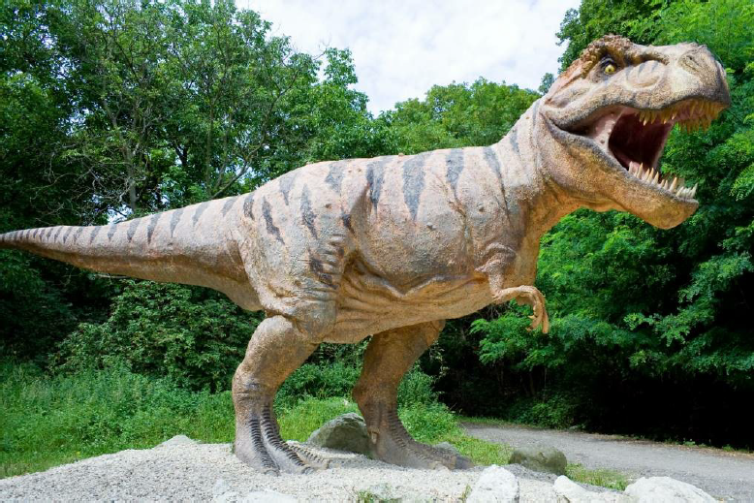

T-Rex Window
431 words
Just as George was being eaten by the T-Rex, he woke up from the terrible dream.
Gasping for air, sweat trickling down his face, he looked around the peace and quiet of his room. It was just a bad dream!
George laughed to himself as he got out of bed slowly. It had seemed so real, like many dreams do. But he was okay. And besides, as he’d learned in school last week, dinosaurs were extinct.
He looked over at the clock and was dismayed to see he’d slept in far too long. He quickly changed his clothes and went to the bathroom to brush his teeth. He then popped open the blinds to greet the sun that poured in and jumped back at the sound of a mighty roar.
Nose pressed to the window, an angry looking T-Rex was glaring at him!
Too shocked to respond, George froze. After what seemed like an eternity, his mom’s angry voice rang from downstairs.
“Georgie! What are you doing? The school bus is here!”
George looked again at the T-Rex and smiled but was not greeted by a smile back. He raced down the stairs to find his mom holding a breakfast bar and his backpack.
“Mom, I can’t go outside. There’s a T-Rex out there!” he said.
His mom shook her head angrily. “I’m not in the mood today Georgie.
You’re going to hold up the bus again,” she said.
“Mom, I’m being serious. If I go outside, the T-Rex is going to eat me!”
“Georgie, I think you should be more worried about what your mom’s going to do to you if you’re late to school again, instead of some silly dinosaur.”
She had a point.
“Dinosaurs are extinct. Right, Mom?” It had to be impossible. He must have still been dreaming. Maybe he still was dreaming now. If I go outside and the T-Rex eats me, I must still be dreaming.
“All I know is, no more Jurassic Park movies for you for a while, Georgie.”
George was starting to come down. It was just too ridiculous to imagine. They’d been talking about dinosaurs at school. He’d been watching movies, even playing a dinosaur hunter computer game. Surely it must be all his imagination!
George thanked his mom and kissed her, then snatched his bag and his breakfast. He put on his backpack, put on his shoes, and went outside to see the bus waiting for him down at the end of the street.
Behind him, he heard a soft, heavy breathing sound and turned to see…

The End?

B2（适用于高中学段）
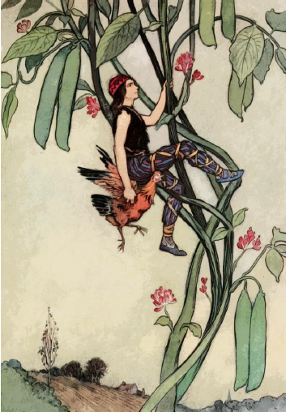

Joe and his Beans
469 words
Joe was walking home from the store one day, a long walk, when the beans his mother had sent him to buy slipped from his hand and into the road he was plowing through.
“Smart move,” he was able to say aloud sarcastically, “I guess I’d better find them.” One problem though—he couldn’t. He thought for a second about what to do, and realizing his only option, he headed back for the store to buy some more beans.
But just as he started, he spotted an old man on the side of the road with a small stand and a sign that read “Delicious Beans for Sale.”
The sight of the old man made Joe think, “Why haven’t I seen this man before?” But even more, why hadn’t he noticed a man selling just beans a lot closer to home than the usual store, a 7-Eleven that had great prices and delicious burritos as well.
Even though he was surprised by this mystery bean seller, Joe wasn’t stupid. So, he walked up to the old man and asked for some beans.
“I need five beans,” Joe said, “I’ll give you seventy-five cents for them.”
Now all he needed was burritos. The old man signaled yes, and he swapped the beans for the dough.
But he said something that surprised Joe, “These are no bad beans, but they ain’t no good ones either.” The old man talked funny with a weird accent. “Just remember, NEVER put them in hot water, okay?”
Joe got a little frightened. He wanted to get away from this man really quick. So, he slinked away, and hurried home to give the beans to his mother.
Joe said, “Here, Mom, sorry I’m late. You can cook these beans, but don’t use hot water, I was warned.”
He thought she got the message, so he went to his room and read a bit and waited.
***
He got a nice surprise at dinner time.
The beans were just sitting in a pot of hot, boiling water. Joe almost fainted in shock! He had no idea what would happen to the beans, and he didn’t want to know. His mom urged him to try one.
“No,” Joe said, “I can’t. I was told not to put them in hot water. Who knows what could happen!”
He imagined the beans growing in his stomach, coming out just like in the Alien movies. He could also see himself gagging and choking and finding out the hard way that these beans and water weren’t meant for each other.
But his mother was determined, and much more stubborn, than he was.
“I will never eat those beans!” Joe said. His fight lasted five minutes, after which he was force-fed one.
As he touched the tip of his tongue…

The End?

