Baxter
Step1. Pre-reading (Approximate 10 mins)
- Lead-in:
1) Free talk:
What pets do you like? Why?
2) Flash:
What does he wish? Did his mum say yes? Why not?
- Talk about the cover:
- What can you see in the picture?
- What’s the title/ name of the story?
- Who wrote the story?
- Talk about the first picture (P2-3)
O-W-I

What I observe
- boy, dog, mum, man
- farm + house
- truck + movers
- …
What I wonder
- What …?
- Why …?
- How …?
- …
What I infer
- move to a new place
- couldn’t go with …
- …
- …
- Set the suspence:
What will happen? If you want to know, please open your book and read the story.

Step2. Whi-reading (Approximate 20 mins)
- Read the story
2. Talk about the story and check out if the prediction the students made are right or not
Beginning
(Setting)
P2-3:
- How do they look? Why?
Middle
(Problem)
P10-11:
- Where is Baxter?
- Did he feel happy? Why?
End
(Solution)
P14-15:
- Is Baxter still sad? Why?
- Why is Polly’s house a good place for Baxter?
Step3. After-reading (Approximate 25 mins)
- Point, listen and read out the story aloud.
- Read the story together.
- Think and talk:
- What does the story remind you of your life?
- Problem &Solutions
- Model:
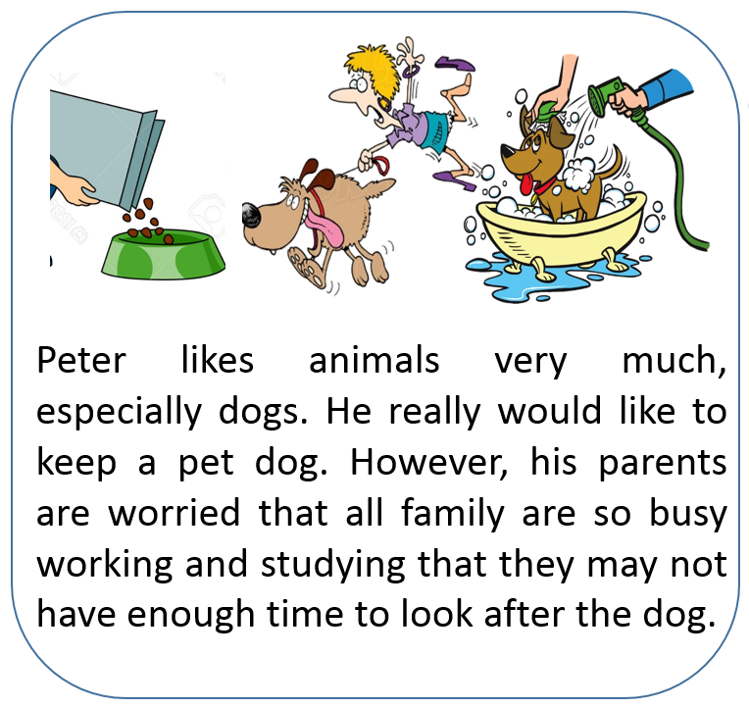
Solutions
- …should ….
- …can ….
- …
- …
- Group work: Read, choose and write.
- Class work: Show and share.

Homework:
Write about a problem in your life and how you solved or plan to solve it.

